**PROJECT REPORT**

1. **INTRODUCTION**
   1. **Overview**

YouTube is a popular online platform that allows users to upload, watch, and share videos. One of the features of YouTube is the ability to subscribe to channels that produce content that interests you. Subscribing to a channel means that you will be notified when new videos are uploaded by that channel, and you can also access their videos more easily from your homepage or subscription feed. In this article, we will introduce you to the list of the most subscribed YouTube channels as of October 2023, based on the official YouTube statistics. We will also briefly describe what kind of content these channels offer and why they are so popular among millions of viewers around the world.

* 1. **Purpose**

The purpose of this text is to provide a brief overview of the list of the most subscribed YouTube channels as of October 2023. YouTube is a popular online video-sharing platform that allows users to upload, watch, comment, and share videos. The number of subscribers is one of the indicators of the popularity and influence of a channel. According to Social Blade, a website that tracks YouTube statistics, the top 10 most subscribed channels as of October 2023 are:

- T-Series: 230 million subscribers. T-Series is an Indian music label and film production company that uploads Bollywood songs and movie trailers.

- PewDiePie: 180 million subscribers. PewDiePie is a Swedish comedian and gamer who posts videos of his reactions and commentary on various games and memes.

- Cocomelon - Nursery Rhymes: 150 million subscribers. Cocomelon is an American channel that produces animated videos for children featuring nursery rhymes and original songs.

- SET India: 140 million subscribers. SET India is an Indian channel that broadcasts shows and movies from Sony Entertainment Television, a Hindi-language entertainment network.

- Kids Diana Show: 130 million subscribers. Kids Diana Show is a Ukrainian channel that features a girl named Diana and her brother Roma playing with toys, dressing up, and having fun.

- 5-Minute Crafts: 120 million subscribers. 5-Minute Crafts is a Cypriot channel that showcases various DIY projects, crafts, hacks, and tips.

- WWE: 110 million subscribers. WWE is an American channel that uploads videos related to World Wrestling Entertainment, a professional wrestling and media company.

**2. PROBLEM DEFINITION & DESIGN THINKING**

**2.1 EMPATHY MAP**

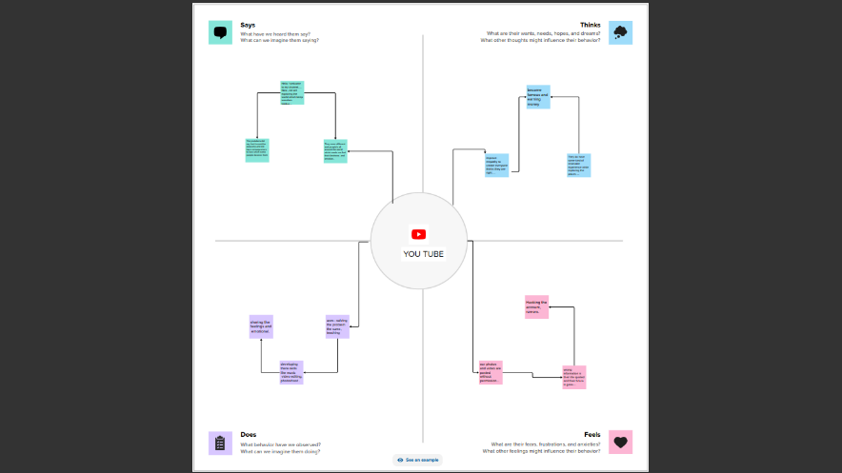

An empathy map is a tool that helps to understand the needs, feelings, and motivations of a target audience. In this case, the target audience is the viewers of the most subscribed YouTube channels. Here is an example of an empathy map for this audience:

- What do they see? They see videos that are entertaining, engaging, informative, or inspiring. They see thumbnails that catch their attention and titles that spark their curiosity. They see comments from other viewers and interactions with the creators.

- What do they hear? They hear the voices, music, sound effects, and background noises of the videos. They hear recommendations from their friends, family, or social media. They hear feedback from the creators and other viewers.

- What do they think and feel? They think and feel different emotions depending on the content of the videos. They may think and feel happy, sad, angry, surprised, amused, bored, interested, or confused. They may also think and feel admiration, respect, envy, or criticism towards the creators.

- What do they say and do? They say and do things that express their opinions, preferences, and reactions to the videos. They may say and do things like liking, commenting, sharing, subscribing, unsubscribing, watching more, or watching less. They may also say and do things that support or challenge the creators.

- What are their pains? Their pains are the problems or frustrations that they face as viewers of the most subscribed YouTube channels. Some of their pains may be: low-quality videos, clickbait titles, misleading thumbnails, annoying ads, offensive content, toxic comments, or inconsistent uploads.

- What are their gains? Their gains are the benefits or satisfactions that they get as viewers of the most subscribed YouTube channels. Some of their gains may be: high-quality videos, accurate titles, appealing thumbnails, relevant ads, positive content, supportive comments, or regular uploads.

**2.2 Ideation & Brainstorming Map**

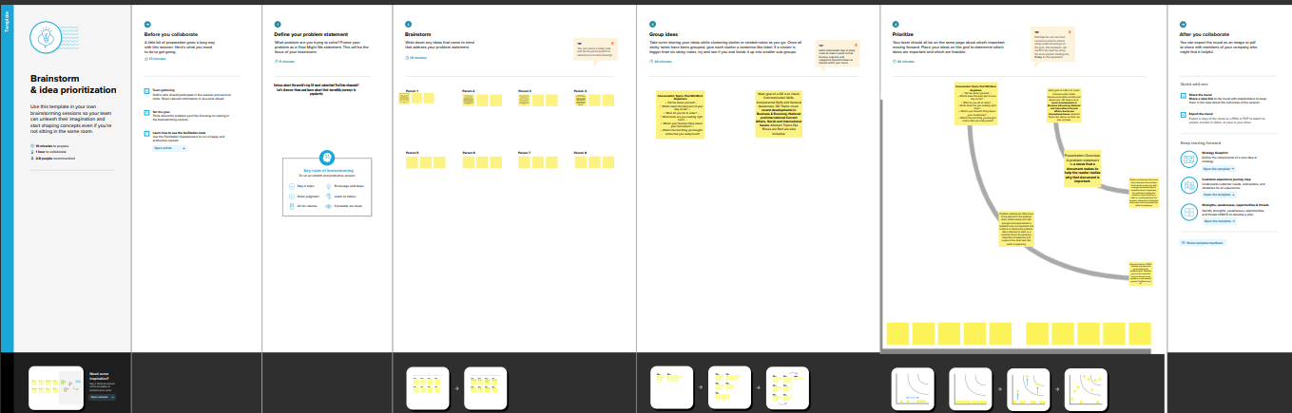

One possible way to brainstorm about the list of most subscribed YouTube channels is to use a combination of data analysis and creativity. Data analysis can help identify the common factors that make a channel popular, such as the genre, the target audience, the frequency and quality of uploads, the engagement with viewers, etc. Creativity can help generate new ideas for content, collaboration, promotion, etc. that can attract more subscribers. A brainstorming session can start with a clear goal, such as increasing the number of subscribers by a certain percentage in a given time frame, and then use various techniques, such as mind mapping, brainstorming questions, brainstorming games, etc. to generate as many ideas as possible without judging or filtering them. The ideas can then be evaluated and prioritized based on their feasibility, originality, impact, etc. and then implemented accordingly.

1. **RESULT**

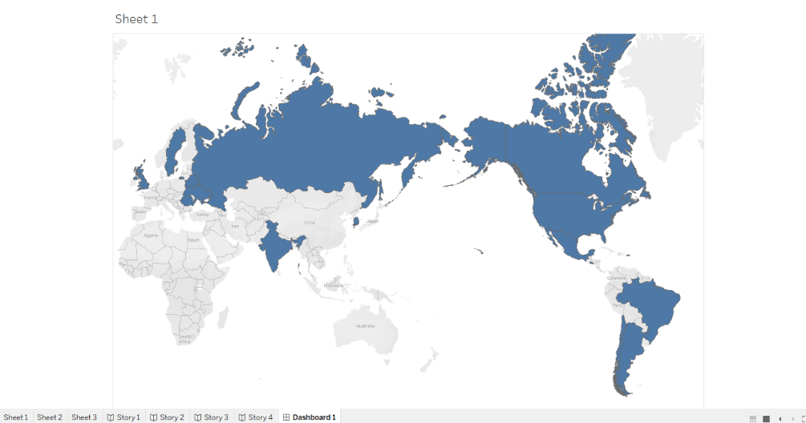

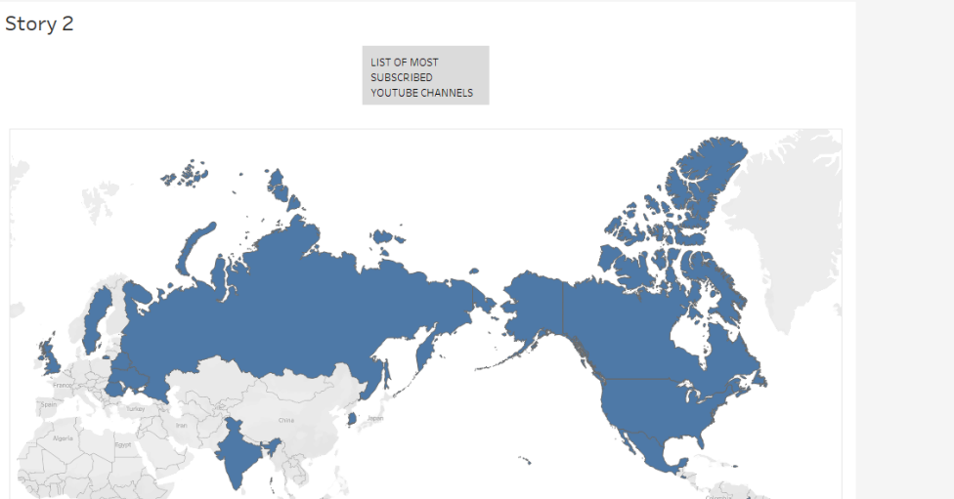

One of the most popular features of YouTube is the ability to subscribe to channels that produce content that interests the user. The list of most-subscribed YouTube channels shows which channels have attracted the most subscribers on the platform. As of October 2023, the most-subscribed channel is T-Series, an Indian record label with over 251 million subscribers. The second most-subscribed channel is MrBeast, an American YouTube personality with over 201 million subscribers. The list also includes channels from various categories, such as music, entertainment, education, and gaming. Some of the channels that have reached more than 45 million subscribers are Badabun, HAR PAL GEO, and Bad Bunny.

**4. ADVANTAGES & DISADVANTAGES**

YouTube is a popular online platform that allows users to upload, watch, and share videos. One of the features of YouTube is the ability to subscribe to channels that produce content that interests the user. Subscribing to a channel means that the user will receive notifications when new videos are uploaded by that channel, and that the channel will appear on the user's homepage and subscription feed. The number of subscribers that a channel has is often used as a measure of its popularity and influence.

There are some advantages and disadvantages of subscribing to the most subscribed YouTube channels. Some of the advantages are:

- The user can access high-quality and diverse content from different genres, such as music, comedy, gaming, education, and more.

- The user can stay updated on the latest trends, news, and events that are relevant to their interests and preferences.

- The user can interact with other subscribers and fans of the channel through comments, likes, and shares, and form a sense of community and belonging.

- The user can support their favorite creators and help them earn revenue from advertisements, sponsorships, and merchandise.

Some of the disadvantages are:

- The user may experience information overload and distraction from too many notifications and videos on their feed, which can affect their productivity and well-being.

- The user may develop unrealistic expectations and comparisons from watching the curated and edited lives of the creators, which can affect their self-esteem and happiness.

- The user may encounter negative or toxic comments from other subscribers or haters of the channel, which can affect their mood and mental health.

- The user may lose interest or trust in the channel if the creator changes their content style, frequency, or quality, or if they are involved in controversies or scandals.

**5. APPLICATIONS**

YouTube is a popular online platform that allows users to upload, watch, and share videos. One of the features of YouTube is the ability to subscribe to channels that produce content that interests the user. Subscribing to a channel means that the user will receive notifications when new videos are uploaded by that channel, and also see the channel's videos on their homepage and subscription feed.

Some YouTube channels have amassed a large number of subscribers, making them among the most influential and successful online personalities. The following is a list of the most subscribed YouTube channels as of October 2023, according to Social Blade, a website that tracks YouTube statistics.

- T-Series: T-Series is an Indian music label and film production company that has been on YouTube since 2006. It is the most subscribed YouTube channel in the world, with over 250 million subscribers. T-Series uploads music videos, movie trailers, and songs from various genres and languages, catering to a diverse and global audience.

- PewDiePie: PewDiePie is a Swedish video game commentator and comedian who has been on YouTube since 2010. He is the second most subscribed YouTube channel in the world, with over 140 million subscribers. PewDiePie is known for his humorous and sometimes controversial videos, where he plays various games, reacts to memes, and interacts with his fans.

- Cocomelon - Nursery Rhymes: Cocomelon - Nursery Rhymes is an American YouTube channel that has been on YouTube since 2006. It is the third most subscribed YouTube channel in the world, with over 130 million subscribers. Cocomelon - Nursery Rhymes produces animated videos for children, featuring songs, stories, and educational content.

- SET India: SET India is an Indian entertainment channel that has been on YouTube since 2006. It is the fourth most subscribed YouTube channel in the world, with over 120 million subscribers. SET India uploads clips and full episodes from various shows that air on Sony Entertainment Television, such as dramas, comedies, reality shows, and talent shows.

- Kids Diana Show: Kids Diana Show is a Ukrainian YouTube channel that has been on YouTube since 2015. It is the fifth most subscribed YouTube channel in the world, with over 110 million subscribers. Kids Diana Show features a young girl named Diana and her family, who make videos about toys, games, adventures, and everyday life.

**6. CONCLUSION**

In this article, we have presented a list of the most subscribed YouTube channels as of October 2023, based on the data from Social Blade. We have also discussed some of the factors that contribute to their popularity, such as content quality, audience engagement, niche appeal, and brand partnerships. We have seen that YouTube is a diverse and dynamic platform that offers opportunities for creators of different genres, styles, and backgrounds to reach millions of viewers around the world. We hope that this article has given you some insights into the current trends and challenges of YouTube content creation, as well as some inspiration for your own channel.

**7. FUTURE SCOPE**

The list of most subscribed YouTube channels is a dynamic and competitive ranking that reflects the popularity and influence of various content creators on the platform. The list is constantly changing as new channels emerge, old ones fade, and some manage to maintain their loyal fanbase. The list can also provide insights into the trends and preferences of the global online audience, as well as the challenges and opportunities for YouTube as a business and a community.

In this report, we will analyze the current list of most subscribed YouTube channels as of October 2023, and discuss the factors that contribute to their success. We will also explore the potential future scenarios for the list, based on the current data and projections. We will examine the possible impacts of these scenarios on the YouTube ecosystem, as well as the implications for content creators, advertisers, and viewers.